2024 BOSTON TEEN ENRICHMENT CAMP

The Journey of Growth

### Setting Sail NOW

#### 07/21-08/02

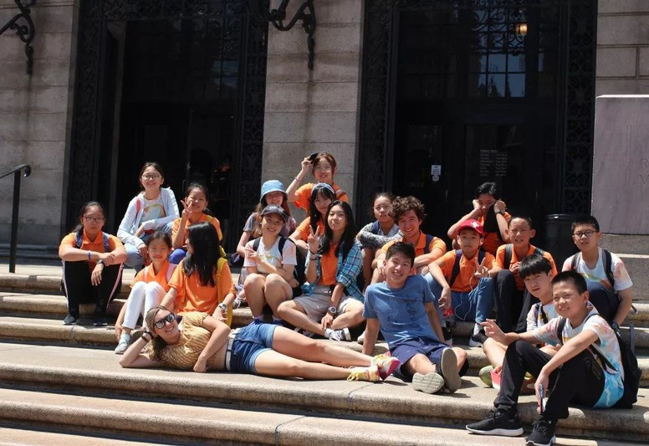It’s gonna be fun!

About US



Boston Teen Enrichment Camp was established in 2015 and has now entered its 9th year. It is a camp dedicated to the growth of children and families, created by a group of educators and psychologists from China and the United States. Since its inception in 2015, the first batch of camp members, even the youngest child who was 10 years old then, is now turning 19 this year. Those campers who were adolescents at the time have grown into adults and achieved success. Among the first batch of campers, two-thirds of the children went to the United States for high school and college. Looking back at the former campers, many of them are now attending top universities in the United States or studying at prestigious American high schools. We are extremely gratified that our camp has silently exerted a positive, proactive, and far-reaching influence on the children. This year, we are setting sail again, and our methods and goals for nurturing children remain consistent:

★ Loving children correctly

★ Accompanying children wholeheartedly

★ Professionally guiding children to become better versions of themselves

"Teen Enrichment" means helping teenagers understand themselves, establish goals, and determine directions. It means helping them learn to overcome difficulties, persevere, and ultimately realize themselves in the meaning of life. We deeply believe that each child is a unique and outstanding individual, each with their own unique dreams and achievements. As educators who deeply love the children and as psychological counselors who care about whether they are happy, we will bless those who are already excellent and accompany them to become better versions of themselves!

##### Harvard Public Speaking Course

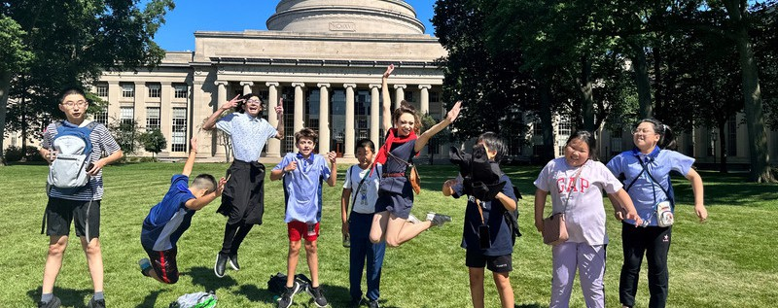

Highlights

Taught by Harvard professors, cultivating leadership and influence hand in hand

##### MIT Science Class

Led by MIT teams, experiencing the charm of scientific research

##### Let’s Talk Workshop

Guided by psychologists Professionally assisting children in establishing self-

motivation and self-awareness

##### Cultural Exchange

Between China and the United States

##### In-depth interaction and exchange

between students from China and the United States, learning from each other, and establishing friendships.

## CAMP DATES

**7/21**

**- 8/2**

**Camper Age: 11-17**

**Teacher Ratio: 1:5**

Since the end of 2015, whether it's the guiding mentors of the TEC, student counselors, or camp attendees, after 9 years, they have all grown into better versions of themselves, each achieving their own dreams. Camp attendees have entered prestigious universities in China such as Tsinghua University, Zhejiang University, and Renmin University, while overseas, they have been admitted to institutions like Columbia University, Harvard University, Massachusetts Institute of Technology, University of Chicago, Northwestern University, Duke University, University of Wisconsin-Madison, University of Michigan, Babson College, New York University, as well as renowned schools in the UK. The guiding mentors of the camp have also pursued further education at institutions like Harvard, Columbia, and Northeastern University, or have established their own careers in various fields. This is truly a camp dedicated to growth, where everyone is growing.

Join TEC, and let's grow each other up!

WEEK 1 SCHEDULE

DAY 1 7/21 SUN

Arrival

DAY 2 7/22 MON

DAY 3 7/23 TUE

DAY 4 7/24 WED

DAY 5 7/25 THU

DAY 6 7/26 FRI

DAY 7 7/27 SAT

THEME

Bre早ak餐fast 8:80:000--89::3000

Morning 9:00-12:00

Lunch 12:00-13:30

Afternoon 13:30-18:00

Dinner 18:00-19:00

Evening 19:00-20:00

Night

Meet counselors at 4 pm at the airport.

集合出发

上午9点在首都国际

机场T2

Arrive in Boston

Boston Day MIT&Science MIT&Science Science & Art

at dorm

MIT&科学

Buffet

MIT Campus Tour

探索发现 MIT校园

MIT

科技课程

MIT

科技课程

MIT

学生餐

MIT STEM

Course

MIT STEM

Course

MIT STEM

Course

MIT STEM

Course

MIT STEM

Course

Freedom Trail

Quincy Market

MIT Cafes

MIT Cafes

MIT Cafes

Duck Tour & Public Garden

Buffet at dorm

MIT

科技课程

Free time and rest

Let’s talk!

Harvard & Impact

Harvard & Impact

Public Speaking

Public Speaking

OTTO Pizza Picnic

Explore Harvard

Whale Watch

/Aquarium

WEEK 2 SCHEDULE

THEME

Breakfast 8:00-9:00

Morning 9:00-12:00

Lunch 12:00-13:30

Afternoon 13:30-18:00

Dinner 18:00-19:00

Evening 19:00-20:00

DAY 8 7/28 SUN

Harvard

Public Speaking

Harvard Cafe

Boston Library Trinity Church Newbury Street

DAY 9 7/29 MON

Harvard

Public Speech

MOS

Cafeteria

Museum of Science

DAY 10 7/30 TUE

US Edu & Me

Buffet

Breakfast

Improv Course

Local Restaurant

Improv Course

Buffet Let’s talk!

DAY 11 7/31 WED

Self- awareness workshop

Authentic Chinese Food

Me & My dream

Improv Course

DAY 12 8/1 THU

My Impact

Visit City Mayor

Buffet

Commencement

DAY 13 8/2 FRI

Impact & Growth

Graduate Speech

Lunch &Rest

Airport

Night

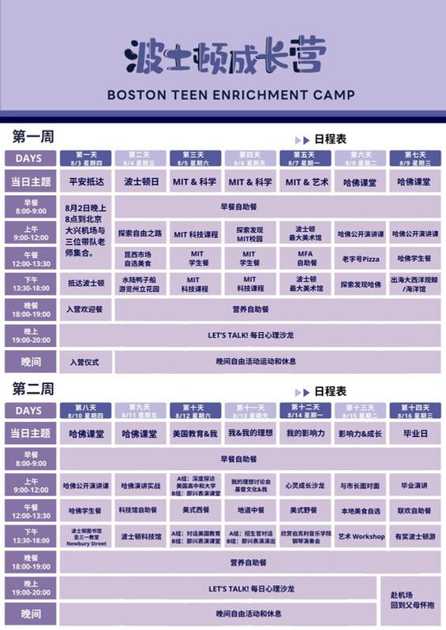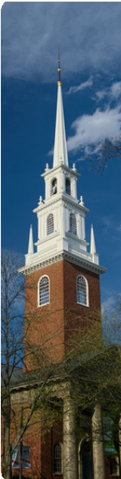

Food Truck

Free time and rest

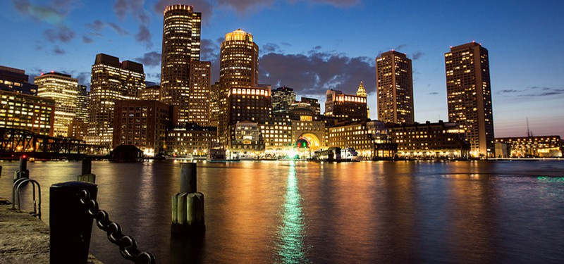**7/21/2024-8/2/2024**

**Daily**

**/IOutr Dailiy Fonotprintse/**

# rary

|  |  |  |  |  |
| --- | --- | --- | --- | --- |
| **DAYS** |  | **THEME** |  | **SCHEDULE** |

|  |  |  |  |  |
| --- | --- | --- | --- | --- |
| **DAY 1**  **7/21 Sun** |  | **Departure and Arrival** |  | Leave for Beijing Daxing Airport after breakfast. Gather at 9 AM.  Bring some food to eat while waiting at the airport.  Arrive in Boston local time on July 17th at 4 PM, greeted by Chinese and American teachers.  **5:00 pm** Check into downtown Boston apartments (dormitory of an American high school).  **6:00-7:00 pm** Buffet dinner at the apartment restaurant.  **7:00-8:00 pm** Opening ceremony, overview of daily courses, and collectively establish camp safety and other rules.  **8:00-8:30 pm** Camp reporters share the day's observations and thoughts in the group. |

|  |  |  |  |  |
| --- | --- | --- | --- | --- |
| **DAY 2**  **7/22 Mon** |  | **Boston Day** |  | **8:00-8:30 am** Buffet breakfast at the apartment restaurant.  **9:00-12:00 pm** Follow a renowned American guide on a mission to retrace the Freedom Trail, the path to American independence, visiting 16 historical sites along the way.  **12:00-1:30 pm** Choose local cuisine at the famous Quincy Market and watch street performers.  **2:00-5:00 pm** The best way to fight jet lag is to take a Duck Tour, breezing through Boston and cruising on the Charles River, overlooking Harvard and MIT.  **6:00-7:00 pm** Buffet dinner at the apartment restaurant.  **7:00-8:00 pm** Let’s Talk activity  **8:00-8:30 pm** Camp reporters share the day's observations and thoughts in the group. |

|  |  |  |  |  |
| --- | --- | --- | --- | --- |
| **DAY 3**  **7/23 Tue** |  | **MIT&Science Day** |  | **8:00-8:30 am** Buffet breakfast at the apartment restaurant.  **9:00-12:00 pm** Visit MIT campus and experience MIT labs with the MIT team.  **12:00-1:30 pm** Choose your favorite food at a restaurant frequently visited by MIT students and professors, experiencing MIT student life.  **1:30-6:00 pm** Learn STEM courses at MIT.  **6:30-7:00 pm** Buffet dinner at the apartment restaurant.  **7:00-8:00 pm** Let’s Talk activity  **8:00-8:30 pm** Camp reporters share the day's observations and thoughts in the group. |

Daily Itinerary



|  |  |  |
| --- | --- | --- |
| **DAYS** | **THEME** | **SCHEDULE** |
| **DAY 4**  **7/24 Wed** | **MIT &**  **Science** | **8:00-8:30 am** Buffet breakfast at the apartment restaurant.  **9:00-12:00 am** Learn MIT STEM courses at MIT.  **12:00-1:30 pm** Choose your favorite food at a restaurant frequently visited by MIT students and professors, experiencing MIT student life.  **1:30-4:30 pm** Continue the journey of MIT STEM courses at MIT.  **6:30-7:00 pm** Buffet dinner at the apartment restaurant.  **7:00-8:00 pm** Let’s Talk activity  **8:00-8:30 pm** Camp reporters share the day's observations and thoughts in the group. |

|  |  |  |
| --- | --- | --- |
| **DAY 5**  **7/25 Thu** | **Science & Art** | **8:00-8:30 am** Buffet breakfast at the apartment restaurant.  **9:00-12:00 pm** Learn MIT STEM courses at MIT.  **12:00-1:30 pm** Choose your favorite food at a restaurant frequently visited by MIT students and professors, experiencing MIT student life.  **1:30-4:30 pm** Continue the journey of MIT STEM courses at MIT.  **6:00-7:00 pm** Buffet dinner at the apartment restaurant.  **7:00-8:00 pm** Let’s Talk activity  **8:00-8:30 pm** Camp reporters share the day's observations and thoughts in the group. |

|  |  |  |
| --- | --- | --- |
| **DAY 6**  **7/26 Fri** | **Harvard & Impact** | **8:00-8:30 am** Buffet breakfast at the apartment restaurant.  **9:00-12:00 pm** Immerse in a Harvard classroom, where Harvard professors train campers in public speaking.  **12:00-1:30 pm** Experience Harvard's most popular Pizza, picnic on Harvard campus, experiencing Harvard student life.  **1:30-5:00 pm** Spend the afternoon with Harvard students, completing a Scavenger Hunt challenge.  Practice public speaking back at the apartment.  **6:00-7:00 pm** Buffet dinner at the apartment restaurant.  **7:00-8:00 pm** Let’s Talk activity  **8:00-8:30 pm** Camp reporters share the day's observations and thoughts in the group. |

|  |  |  |
| --- | --- | --- |
| **DAY 7**  **7/27 Sat** | **Harvard & Impact** | **8:00-8:30 am** Buffet breakfast at the apartment restaurant.  **9:00-12:00 pm** Immerse in Harvard’s public speaking class classroom, where Harvard professors train campers in public speaking.  **12:00-1:00 pm** Experience the student food trucks at Harvard Square. Remember to chat with Harvard students around you.  In the afternoon, go whale watching at sea. Whales and dolphins can be seen nearby, joyfully swimming and playing, experiencing the wonders and beauty of nature. If you get seasick, you can choose to visit the largest oceanarium in Boston for a close encounter with marine animals.  **6:00-7:00 pm** Buffet dinner at the apartment restaurant.  **7:00-8:00 pm** Let’s Talk activity  **8:00-8:30 pm** Camp reporters share the day's observations and thoughts in the group. |

Daily Itinerary



|  |  |  |
| --- | --- | --- |
| **DAYS** | **THEME** | **SCHEDULE** |
| **DAY 8**  **7/28 Sun** | **Harvard** | **8:00-8:30 am** Buffet breakfast at the apartment restaurant.  **9:00-12:00 am** Participate in Harvard's public speaking class, Session 1.  **12:00-2:00 pm** Experience American cuisine at a restaurant on Newbury St.  **2:00-5:00 pm** Study and practice public speaking at the first and most magnificent public library in the United States. Take a break from practice to visit the historic Trinity Church and stroll along Newbury Street, which has been around for over two hundred years.  **6:00-7:00 pm** Buffet dinner at the apartment restaurant.  **7:00-8:00 pm** Let’s Talk activity  **8:00-8:30 pm** Camp reporters share the day's observations and thoughts in the group. |

|  |  |  |
| --- | --- | --- |
| **DAY 9**  **7/29 Mon** | **Harvard** | **8:00-8:30 am** Buffet breakfast at the apartment restaurant.  **9:00-12:00 pm** Participate in Harvard's public speaking class, Session 2.  **12:30-13:30 pm** Dine at the museum restaurant located by the beautiful Charles River at the largest science museum in Boston.  **1:30-5:00 pm** Watch lightning shows, conduct experiments, witness science demonstrations, and explore various exhibitions based on personal preferences at the science museum.  **6:00-7:00 pm** Buffet dinner at the apartment restaurant.  **7:00-8:00 pm** Let’s Talk activity  **8:00-8:30 pm** Camp reporters share the day's observations and thoughts in the group. |

|  |  |  |
| --- | --- | --- |
| **DAY 10**  **7/30 Tue** | **US Edu & Me** | **8:00-8:30 am** Buffet breakfast at the apartment restaurant.  **9:00-12:00 pm** Improvisation Performance Workshop, learning how to express oneself and enhance one's influence with the Harvard team.  **12:00-1:00 pm** Enjoy authentic Chinese cuisine, a taste of long-missed delicacies. **1:30-4:30 pm** Continue the Improvisation Performance Workshop, uncovering one's potential and breaking through self-limitations.  **4:30-6:00 pm** Free time and rest at the apartment, preparing for the performance on the following day.  **6:00-7:00 pm** Buffet dinner at the apartment restaurant.  **7:00-8:00 pm** Let’s Talk activity.  **8:00-8:30 pm** Camp reporters share the day's observations and thoughts in the group. |

|  |  |  |
| --- | --- | --- |
| **DAY 11**  **7/31 Wed** | **Me &**  **My dream** | **8:00-8:30 am** Buffet breakfast at the apartment restaurant.  **9:00-12:00 pm** Psychological Salon - Self Growth. Explore and discover oneself with a psychology professor, seeking the path of personal development.  **12:00-1:30 pm** Experience the most popular and common Dunkin' food in the United States.  **2:00-5:00** Improvisational Performance Showcase.  **6:00-7:00 pm** Buffet dinner at the apartment restaurant.  **7:00-8:00 pm** Let’s Talk activity  **8:00-8:30 pm** Camp reporters share the day's observations and thoughts in the group. |

Daily Itinerary



|  |  |  |
| --- | --- | --- |
| **DAYS** | **THEME** | **SCHEDULE** |
| **DAY 12**  **8/1 Thu** | **My Impact** | **8:00-8:30 am** Buffet breakfast at the apartment restaurant.  **9:00-10:00 pm** Pre-visit discussion and practice for the City Hall tour and symposium. **11:00-12:00 pm** Visit Cambridge City Hall, meet with the Mayor of Cambridge, and engage in a discussion.  **12:30-1:30 pm** Buffet lunch at the art museum.  **2:00-5:00 pm** Visit the most famous art museum in Boston, USA.  **6:00-7:00 pm** Buffet dinner at the apartment restaurant.  **7:00-8:00 pm** Let’s Talk activity  **8:00-8:30 pm** Camp reporters share the day's observations and thoughts in the group. |

|  |  |  |
| --- | --- | --- |
| **DAY 13**  **8/2 Fri** | **Impact & Growth** | **8:00-8:30 am** Buffet breakfast at the apartment restaurant.  **8:30-9:30 pm** Pack up and check out of the room, ensuring to inspect personal belongings to avoid leaving anything behind.  **9:30-12:30 pm** Campers will individually deliver speeches, sharing their growth experiences at the camp and their outlook on future learning. Outstanding students and teams will be awarded by Harvard professors and mentors.  After a brief lunch break, depart for Logan Airport to begin the journey back to the embrace of our homeland! |

###### PS: Due to weather and other uncontrollable factors, temporary adjustments to the itinerary may be made. Course content may also be customized based on the specific personalities and needs of the camp members. We also offer custom services for visiting American high schools and universities. Feel free to consult us.

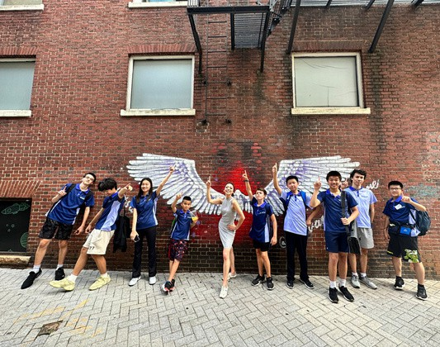 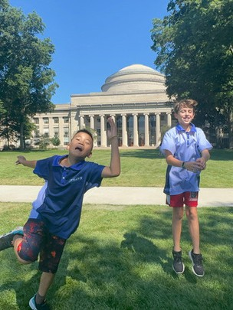

## Past Event Highlights



8

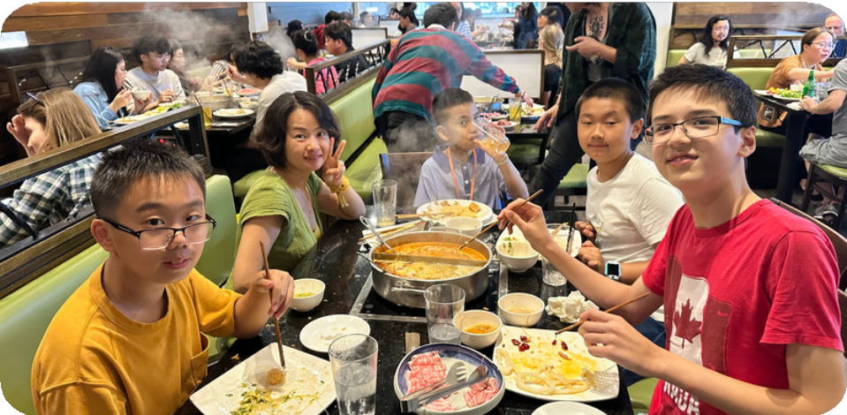

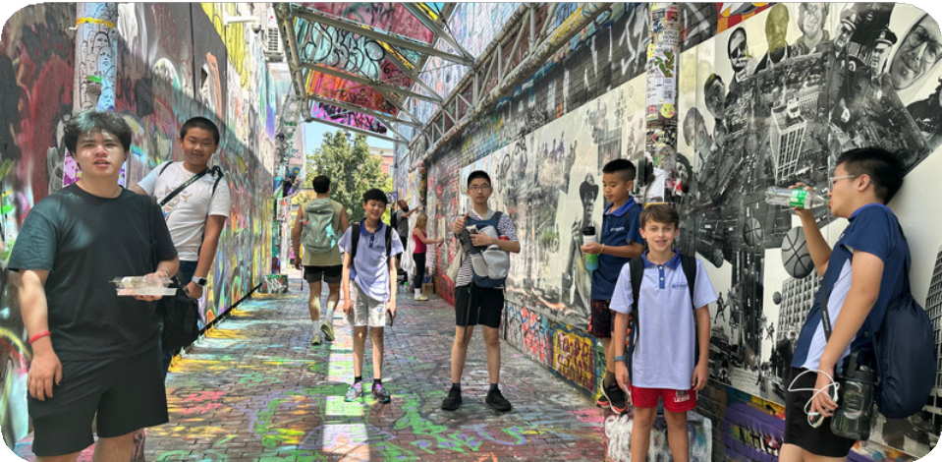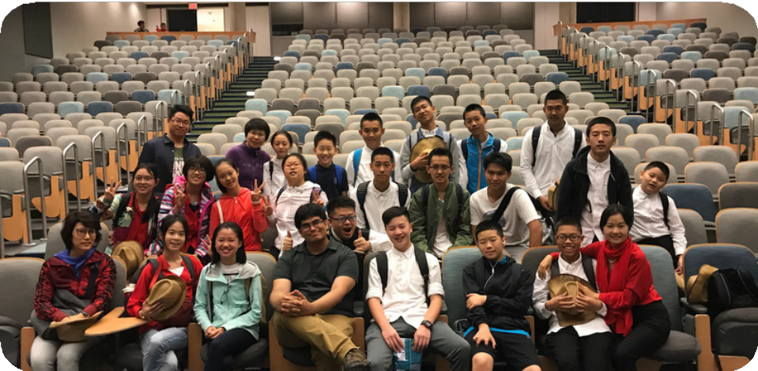

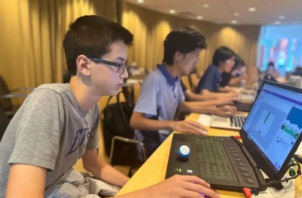 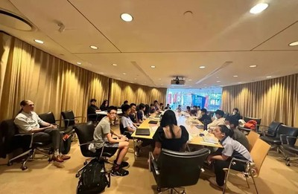

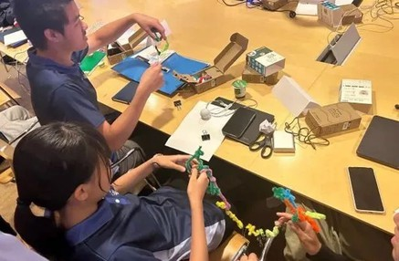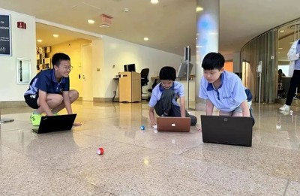

**S TEM Activity at MIT**

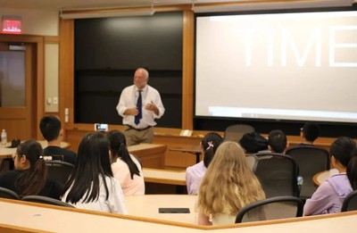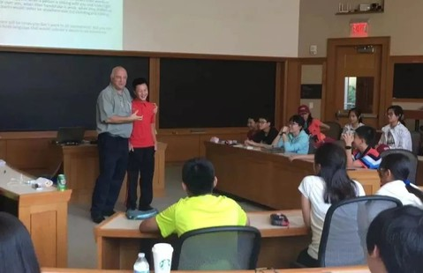

**Public S peaking with Harvard Profes s or**

**at MIT Lab**

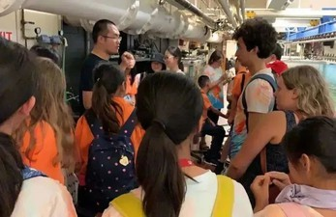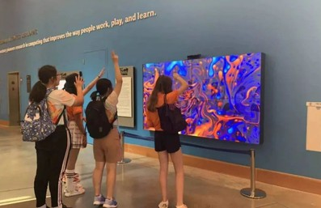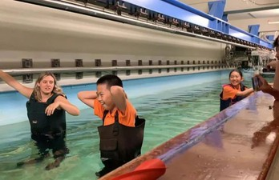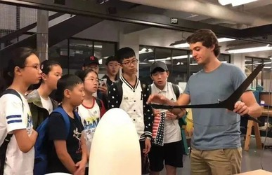

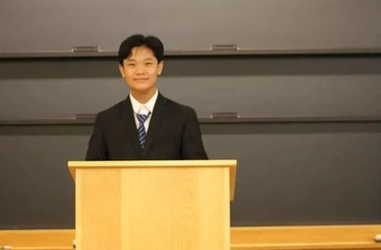 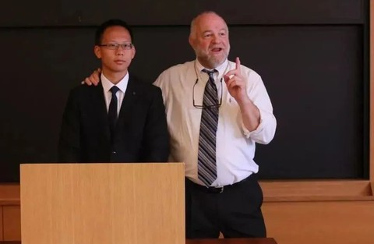

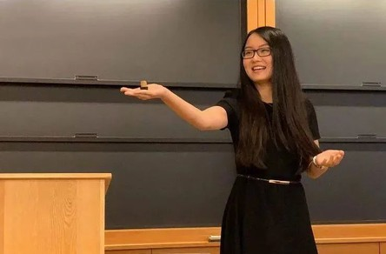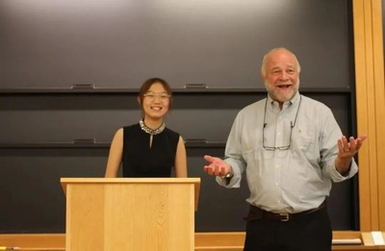

**At Harvard Law S chool**

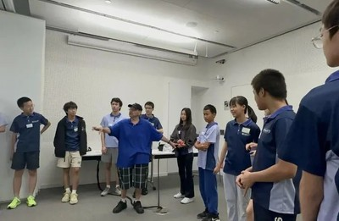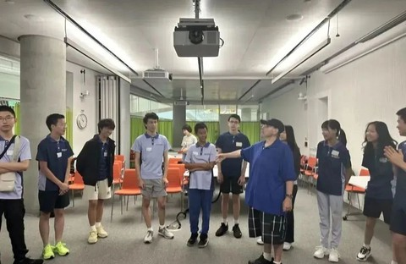

**In Harvard Public S peaking Clas s**

**Whale Watch**

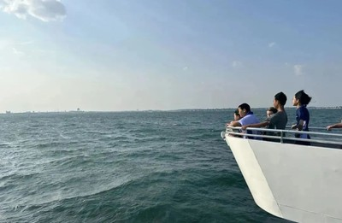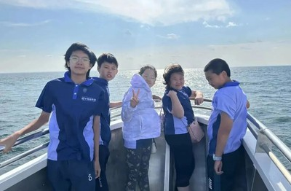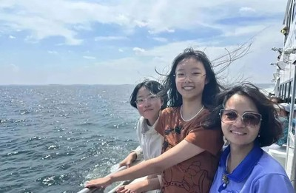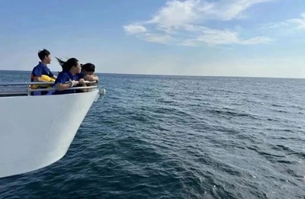

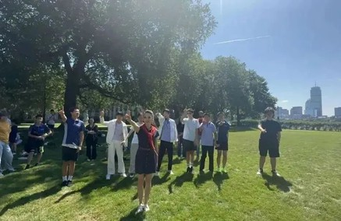 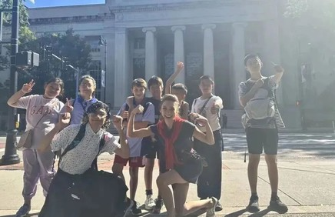

**At MIT campus**

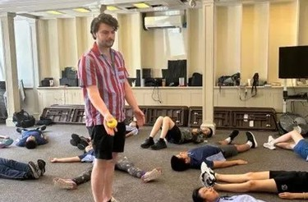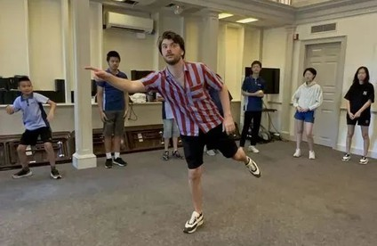

**Harvard Improv Clas s**

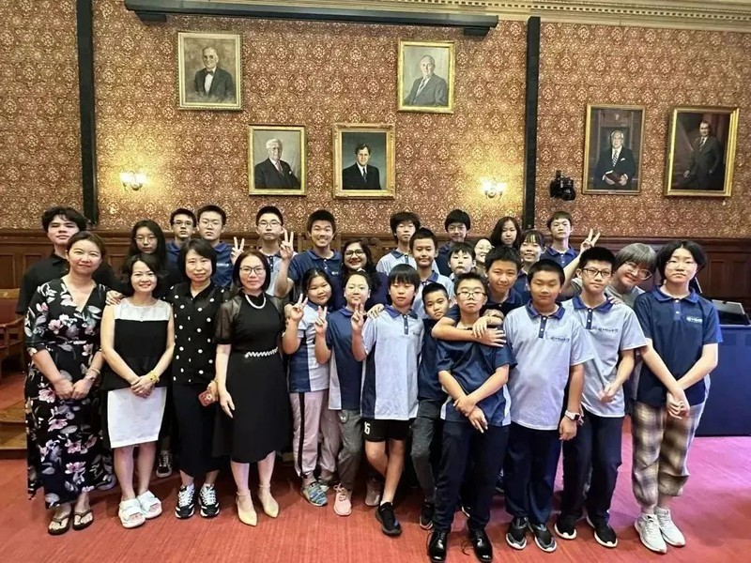

**Meeting with the Mayor**

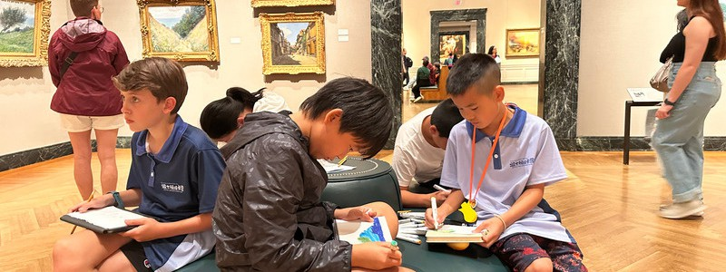

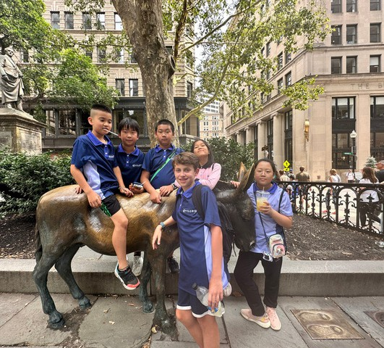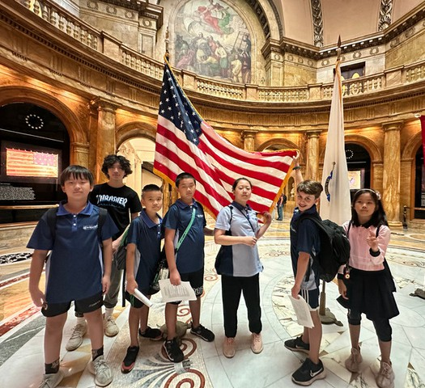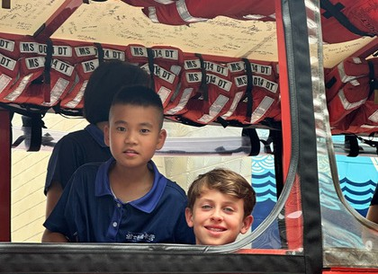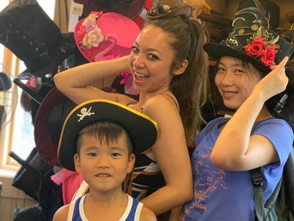

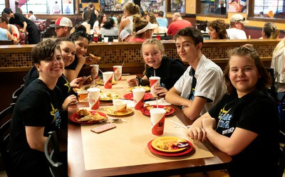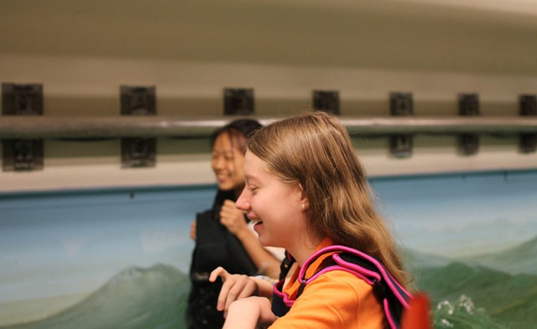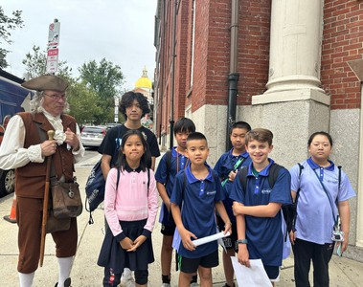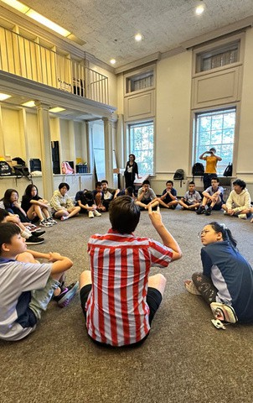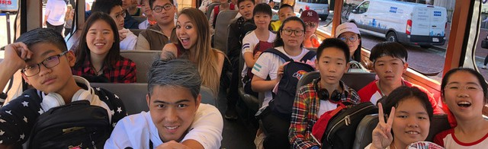

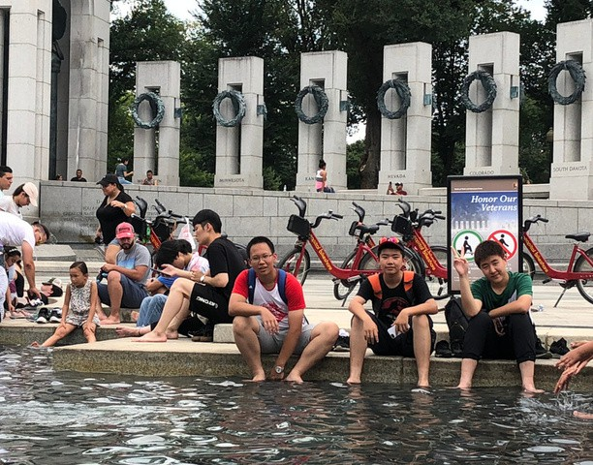

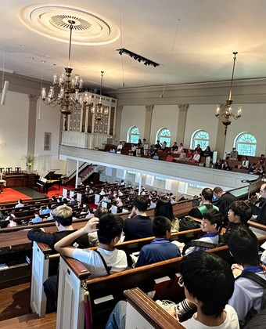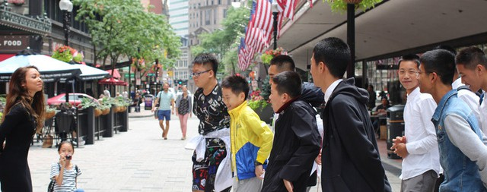

Reviews



4

William's Mom:

What makes our family most delighted is the earth-shaking changes in Weiwei's confidence and leadership before and after this summer camp! Before going to the camp, he was the troublesome kid in the class, but in this semester's class speech campaign for the class monitor, he won by a majority vote and obtained the position of the class monitor, which I couldn't believe before because he used to ignore these class activities completely. Now, not only does he dare to think and do, but he also succeeds! In his own words: "I can give speeches at Harvard University in the United States and stand on the same stage as the mayor of the United States. Our high school's stage is no longer that big to me!"

Ivy's Mom:

This summer, I had the privilege of signing up for the H&M Teen Enrichment Camp. Initially, I just wanted my child to go abroad, broaden their horizons, and gain more experience. The gains from this summer camp far exceeded this goal. The summer camp not only arranged rich activities and provided high-quality resources from top universities like Harvard and MIT but also had unique and advanced ideas in education or learning guidance. Several keywords left a deep impression, such as: Teen Enrichment Camp, customized courses and activities tailored to the characteristics of children, English language proficiency training, professional psychological observation and growth guidance, nurturing love, kindness, and social responsibility, international vision, and exploratory spirit, and so on.

Trey's Mom :

Since returning from the Teen Enrichment Camp, I have seen my child memorizing words relentlessly every day and persisting in listening without being reminded. I feel the momentum inside him that he must learn something new. We are far away in Inner Mongolia, and meeting you was lucky for my child.

Jennifer's Mom:

After returning from the camp, she is healthy and radiant! Children broaden their horizons, learn knowledge, experience the care and respect of teachers and host families, and gain the friendships of peers they most desire and cherish at their age. Here, teachers guide them to discover their true selves and instill scientific sentiments, and even Harvard's famous professors personally teach speech techniques. Children become more and more confident during the activities.

This summer camp, without flashy advertisements or dazzling rhetoric, relies on word of mouth between children and parents. To put it simply, it depends on reputation and emphasizes quality. Especially during the camp in the United States, I saw children with smiles every day, fully relaxed emotions, fully displayed characteristics, and fully blossoming nature. The children gladly complete the learning content designed by TEC.

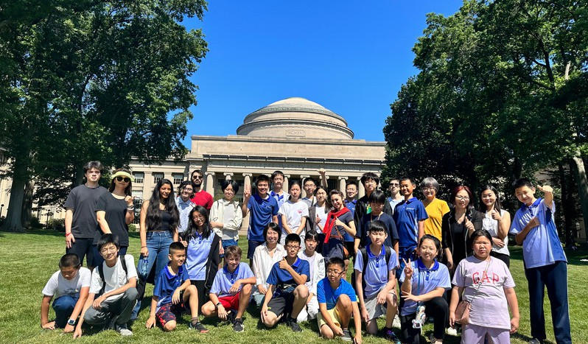

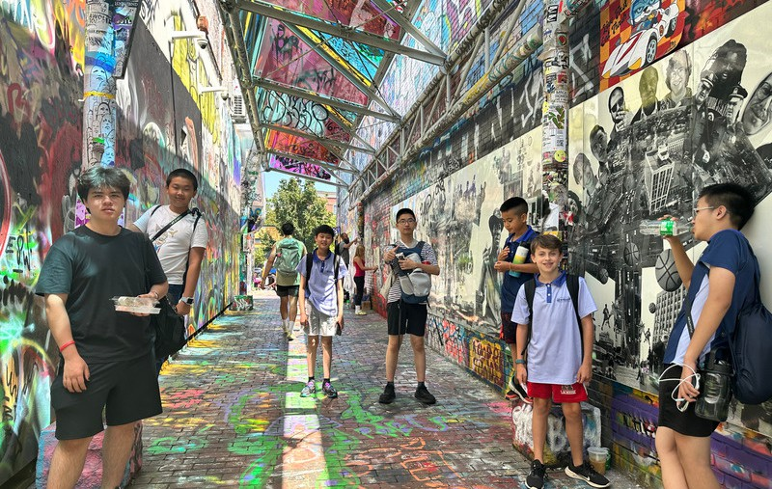

### Tuition

1. **Local Students：$5500**
2. **International Students: $7000**

**Includes：**

* 1. 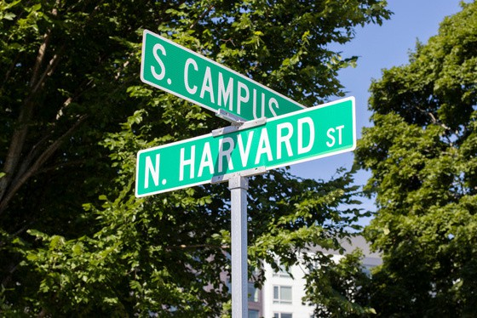Public Speaking course
  2. STEM course
  3. Improv Course
  4. 12 nights boarding
  5. In Camp transportation
  6. Attraction tickets
  7. All meals
  8. Camp certificate
  9. Camp T-shirt
  10. Camp backpack